**Research for Equalizing of the Illumination of the Underwater Image Using the Artificial Illumination**

Masato Shintoa,*, Lifeng Zhanga

a1-1sensui-cho Tobataku, Kitakyushu city, Fukuoka Japan 804-8550

Kyushu Institute of Technology

*Corresponding Author: n108063m@mail.kyutech.jp

**Abstract**

In this paper, we describe the simulation results to improve visibility of deep sea image with difference in luminance by changing several DCT coefficients. DCT is used as the main technique.

In DCT, pixel values of an image which is a discrete signal are converted into a frequency domain and concentrated in a low frequency domain. Human eyes are sensitive to changes in low frequency components. Therefore, by changing the low frequency component, it is possible to create an image easy for human beings to see.

**Keywords**: DCT coefficients, Gaussian filter, luminance.

1. **Introduction**

In recent years it has been confirmed that abundant resources exist in the ocean floor in Japan's economic watershed. For example, there are submarine hydrothermal deposits, methane hydrate, cobalt crust, and so on. Furthermore, in order to adapt to harsh environmental conditions such as high water pressure, low water temperature, darkness and low oxygen condition, organisms have evolved independently, and there is a unique form / ecology that can’t be imagined from the mesopelagic species.

The deep sea generally refers to a place with a water depth of 200 m or less. This proportion accounts for approximately 95% of the ocean. Fine particles and water molecules present in water have the property of absorbing sunlight. The energy of the sun's light is about 0.1% of the surface of the sea near the water depth of 200 m, and general phytoplankton is said to be the limit of photosynthesis. So, when the water depth exceeds 200 m, the sight becomes dark and human eyes can’t recognize the object. Therefore, artificial lighting is indispensable in deep sea surveys. Normally, the illumination is directed to the target object. There are creatures which avoid the light so it is necessary to reduce luminous intensity. Bright parts and dark parts are generated in the image because the illuminance is decreased. Then, using the image processing, reduce the bright and dark areas in the image

1. **Principle**
   1. **YCbCr**

The color is expressed in three primary colors of light of RGB (red, blue, yellow). Human eyes are sensitive to changes in brightness, but they are insensitive to color change. Therefore, in the current image technology, image processing is carried out by decomposing colors into YCbCr (luminance, hue / saturation of red system, hue / saturation of blue system) components. So convert the input RGB component to the YCbCr component in order to equalize the illuminance of the whole image.

In a general color image, one pixel is represented by a total of 24 bits of 8 bits (0 to 255) of R, G and B. When these are converted to YCbCr, they take the following values.

|  |  |
| --- | --- |
| $Y=0.299R+0.587G+0.114B$ | (1) |
| $$Cb=\left(B-Y\right)0.564+delta$$ | (2) |
| $$Cr=\left(R-Y\right)0.713+delta$$ | (3) |

RGB is the value of R, G, B of each pixel, and delta is categorized as follows.

* 1. **DCT(Discrete Cosine Transform)**

DCT (Discrete Fourier Transform) is a method of converting discrete signals to frequency domain. DCT transforms a finite number sequence into coefficients of a linear combination based on a cosine function number sequence. The cosine function returns real number if the input is real number. In addition, there is a property that information concentrates on low frequency components. It is suitable for data compression because information on high frequency components is difficult for humans to recognize. IDCT (Inverse Discrete Fourier Transform) is a method of converting frequency domain to discrete signals. DCT and IDCT are expressed by the following formulas.

|  |  |
| --- | --- |
| $F\left(i,j\right)=C\left(i\right)C\left(j\right)$ $$\sum_{x=0}^{M-1}{\sum_{y=0}^{N-1}{f\left(x,y\right)cos\frac{(2x+1)iπ}{2M}cos\frac{(2y+1)jπ}{2N}}}$$* | (4) |
| $f\left(x,y\right)=\frac{4}{MN}$ $$\sum_{i=0}^{M-1}{\sum_{j=0}^{N-1}{C\left(i\right)C(j)F(i,j)cos\frac{(2x+1)iπ}{2M}cos⁡\frac{(2y+1)jπ}{2N}}}$$* | (5) |

$f\left(x,y\right)$: Two dimensional discrete signal value of input image(x=0,1,…M-1, y=0,1,…N-1)

$F\left(i,j\right)$: Two dimensional DCT coefficient value after DCT(i=0,1,…M-1, j=0,1,…N-1)

M is the height of the image and N is the width of the image.

* 1. **Gaussian Filter**

In the moving average filter, the target pixel is placed in the center of an odd square type kernel with one side of 3 or more. Next the pixel value in the square divides by the square number of length of one side. Finally, the pixel values are averaged by returning their sum to the target pixel. In many cases, the pixel value close to the pixel of interest is approximately equal to the pixel value of the pixel of interest, and the difference from the pixel value of the pixel of interest increases as the distance from the pixel of interest increases. Taking this into consideration, it is the Gaussian filter that the weight at the time of calculation is made larger as closer to the pixel of interest, and the weight is made smaller as it gets farther. This filter uses the following Gaussian distribution function.

|  |  |
| --- | --- |
| $$g\left(x,y\right)=\frac{1}{2πσ^{2}}exp⁡(-\frac{x^{2}+y^{2}}{2σ^{2}})$$ | (6) |

$g\left(x,y\right)$: Two dimensional discrete signal value of input image

$σ$　: Standard deviation

$σ^{2}$: Dispersion

1. **Experimental Method**
2. **Proposed method**

Underwater image converts to YCbCr and sets the image of Y component as the original image. Do the DCT conversion and save the DC component at the upper left end. Using several shapes to set the value of the DCT coefficient in that region to zero. The shape to be used is shown in Fig.1. The DCT coefficient of the white area in Fig.1 is set to 0. Substitute the stored DC component for the DCT coefficient at the upper left corner. Do the IDCT conversion.

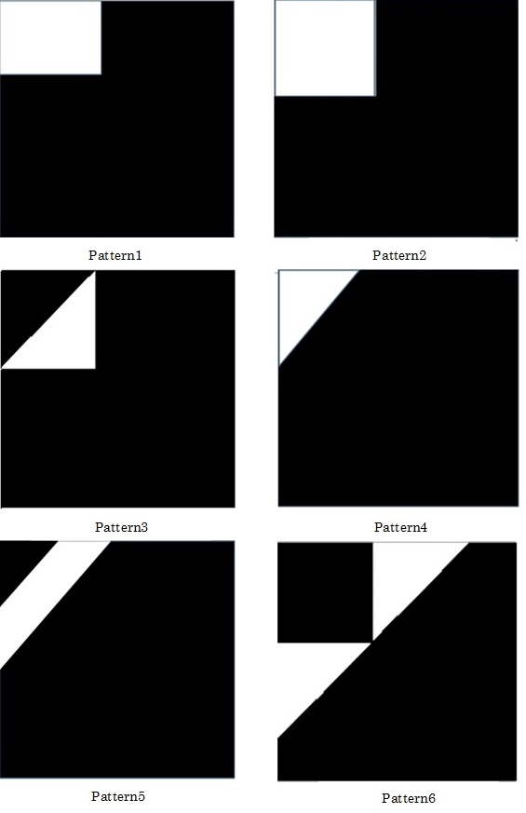

Fig. 1. Shapes to use.

1. **Existing method**

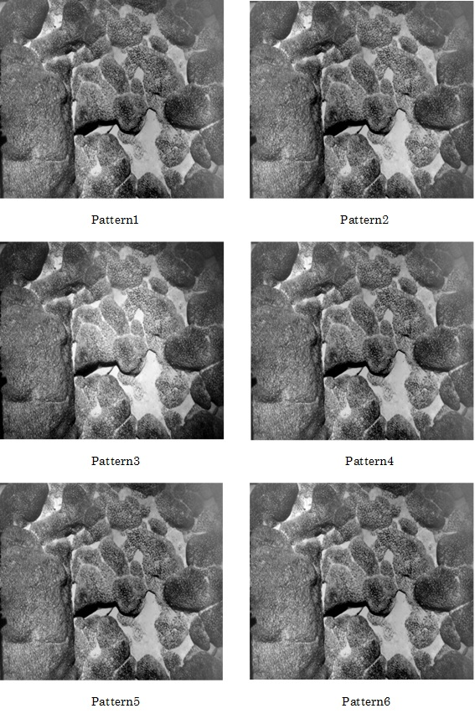

Fig. 4. Proposed Result.

Apply a Gaussian filter to the original image and create luminance distribution of image. Take the difference in luminance distribution created from the original image. An image of luminance distribution is shown in Fig.2.

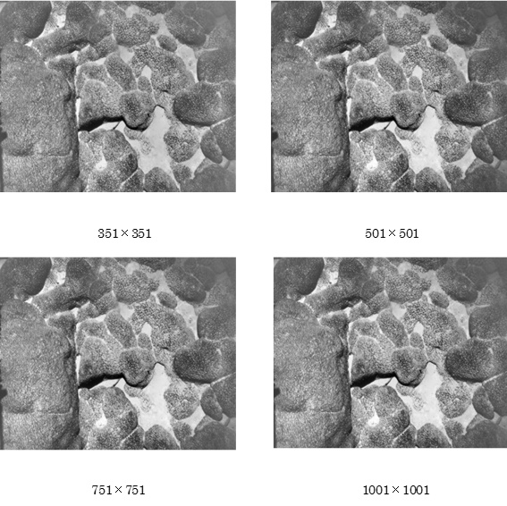

Fig.5. Conventional Method.

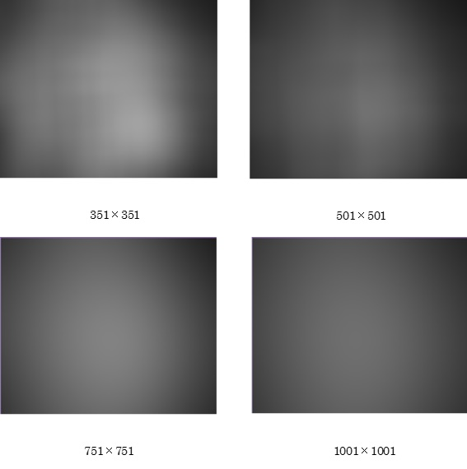

Fig. 2. Luminance Distribution.

1. **Result**

Table 1. Title.

|  |  |  |
| --- | --- | --- |
| Text | Text | Text |
| 0.0 | 1.0 | 2.0 |
| 3.0 | 4.0 | 5.0 |
| 6.0 | 7.0 | 8.0 |

The image after the YCrCb conversion is as shown in Fig.3The result of the proposed method is as shown in Fig.4. The result of the conventional method is as shown in Fig5.

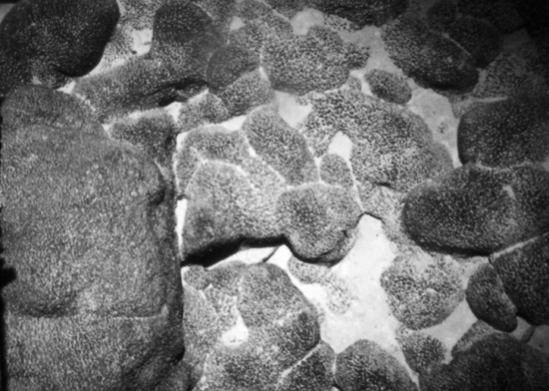

Fig. 3. Original Image.

1. **Conclusions**

From the results obtained from experiments, it is considered that cutting out patterns 1, 2, and 4 is suitable for equalizing the illuminance of the current image. Because the black part of the screen edge approaches white when comparing the Y image after IDCT conversion with the original image, the white part in the center of the screen is approaching black, and the gray part increases as you look through the whole image.

**References**

1. JAMSTEC : Undersea Research and Development Center,

https://www.jamstec.go.jp/shigen/j/exploration/shigen.html

1. GODAC : International Marine Environment Information Center,

http://www.godac.jp/education/deepsea.html